Hi There!


Thanks for downloading these Professional Bio Templates.

Instructions on How to Use This Resource
This template contains 50 professional biography templates for your website, social media bio, speaker introduction or whatever purpose you like.

Simply jump to the professional bio type you’re looking for in the table of contents, choose the template you want to use, customize it to your needs, and copy and paste it to your destination.

We’ve created a bunch of options for you to choose from, so feel free to play around with different templates to see which one works the best for you.

Table of Contents
- Third-Person Short Professional Bio Templates
- First-Person Short Professional Bio Templates
- Third-Person Long Professional Bio Templates
- First-Person Long Professional Bio Templates
- Professional Bio Templates for Your LinkedIn Summary

Earn a free certification from HubSpot Academy to add to your professional biography!  Get certified in Inbound Marketing, Sales, and Service fundamentals. It’s a surefire way to impress anyone reading your bio. | 
Take these Courses for Free

(Keep scrolling to templates)
↓↓↓


[NAME] is an experienced ____, ____, and ____. Driven by ____, he/she takes pride in providing the best ____ possible. As a [ENTER JOB TITLE HERE], his/her goals include ____, ____, and ____. In addition to his/her primary job functions, [NAME] has been recognized by ____ for his/her extraordinary commitment to ____.

[NAME]'s passion for ____ can be traced back to ____, where he/she spent significant time working on ____ and ____. As a ____, he/she specializes in ____, ____, and ____.

[NAME] has worked in the ____ industry for ____ years, gaining experience in ____, ____, ____, and ____. As a seasoned [ENTER JOB TITLE HERE], he/she is passionate about advancing ____ and ____. In addition to ____, he/she is also involved in ____ and ____. Outside of the office, [NAME] enjoys ____, ____, and ____.

A pioneer in the ____ space, [NAME] is the [JOB TITLE] at [CURRENT COMPANY]. He/she started his/her career as the [JOB TITLE] at [PREVIOUS COMPANY], before moving on to do ____ at [PREVIOUS COMPANY]. Driven by a mission to ____, [NAME] is best known for inspiring ____ to ____.

[NAME] began his/her career with [COMPANY], gaining unparalleled experience in the ____ space, while also establishing himself/herself as a respected ____. Currently working as a [JOB TITLE] for [COMPANY], [NAME] is widely known for his/her ____, ____, and ____ expertise. While his/her speaking engagements have taken him/her around the world, [NAME] is proud to call [LOCATION] home.

[NAME] is setting a new standard for how to ____, ____, and ____. His/her commitment to ____ is changing the way ____ handle ____ and ____. As [JOB TITLE] at [COMPANY], he/she specializes in ____ and ____.

[NAME] is a [JOB TITLE] specializing in ____, ____, and ____. Check out his/her website [LINK] or say hi on Twitter @YourHandleHere.

[NAME] is the [JOB TITLE] at [COMPANY] and loves helping people ____, ____, and ____. He/she has spent the majority of his/her career in the ___ industry, gaining experiences in areas such as ____, ____, and ____. While ____ is his/her primary job function by day, [NAME] also enjoys ____ and ____.

Based in [Location], [Name] is best known for his/her contributions to ____ and ____. When he/she isn't busy running ____ at [Company], you can find him/her ____, ____, or ____.

[Name] has dedicated his/her/career to helping ____ with ____. As a professional ____, [Name] specializes in ____ and ____. He/She/They are certified in ____ and earned his/her/their degree in ____ from ____.

After earning my [Degree] in [Area of Study] from [School], I entered the [Industry] world to explore my passion for ____, ____, and ____. Currently, I work as a [Job Title] for [Company], where I'm focused on ____, ____, and ____.

I’ve spent the last [Number] years learning everything there is to know about the ___ industry – from ____ to ____. I’m currently applying this knowledge in my role as [Job Title] for [Company], where I’m responsible for ____, ____, and ____.

I've held a number of ____ roles, from [Role 1] to [Role 2], but my latest challenge has been helping [Company] improve ____ and ____ through my contributions as the [Job Title]. You can follow my work here [Personal Website or External Portfolio Link].

I’m a [Job Title] with a passion for ____, ____, and ____. In my [Number] years with [Company], I’ve helped advance ____ and ____.

I am a [Job Title] at [Company] in [Location]. In this role, I ____, ____, and ____. I work with a number of respected ____, including ____, ____, and ____. Prior to [Company], I oversaw ____ at [Previous Company].

With an extensive background in ____, I am an expert on ____ and ____. This work led me to my current role at [Company] where I am responsible for ____, ____, and ____. Some of my current projects include ____ and ____.

My name is [NAME] and I’m a [Job Title] at [Company] based in [Location]. By day, you can find me ____, ____, or ____. By night, I’m typically ____ or ____. Follow along on Twitter: @YourHandleHere.

For most people, ____ doesn’t sound very interesting. For me, ____ is a passion I’ve been chasing for [Number] years. Most recently, my work landed me a position with [Company] where I’m focused on ____, ____, and ____. I guess you could say I’m living the dream.

I’m a ____. I’m a ____. But most importantly, I’m a ____. For more than ____ years, I’ve helped ____ do ____. Now, I work on ____ with ____ to improve ____. You can learn more about me and what I do here: [Insert URL or Social Media Handle].

For over [Number] years, [Name] has been a noteworthy leader in the ____ space. You may know him/her from his/her work as the [Job Title] at [Company], but [Name] can also be credited with contributions to ____, ____, and ____.

[Name] has been honored with [Awards/Recognition] for his/her contributions to ____. He/She holds a [Degree] from [School] and currently resides in [Location].

[Name] has led an impressive career as a ____ and ___ in his/her [Number] years working in the ____ industry. In [Year], he/she was named [Award/Recognition] by [Company] for ____. [Name] has also been featured in several well-known industry publications, including ____, ____, ____, and ____.

Serving as the [Job Title] at [Company], [Name] plays a major role in ____, ____, and ____. Through his/her commitment to this role, he/she has helped [Company] improve ____, ____, and ____.

Prior to his/her current role at [Company], [Name] worked as a [Previous Role at Current Company], helping our ___ team/division with ____, ____, and ____. Before joining the [Company] team, he/she was [Previous Title] at [Previous Company] from [Start Year]-[End Year].

A self-described ____, [Name] is a [Job Title] who is committed to ____ and ____. He/she has spent the last [Number] years creating ____, and is currently most passionate about the work he/she is doing to ____.

As a [Previous Role] turned [Current Role], [Name] has developed a unique perspective when it comes to ____. Influenced by ____ and ____, he/she aspires to ____ in the next stage of his/her career.

[Name] is the [Job Title] at [Company]. Prior to [Company], [Name] was a [Previous Job Title 1] at [Previous Company 1], a ____ in the ____ space. Previously, he/she was a [Previous Job Title 2] at [Previous Company 2].

He/she has contributed to a number of different industry publications/charities/events/organizations, including ____, ____, and ____.

He/she has a [Degree] from [School] and a [Second Degree] from [Second School].

In his/her spare time, he/she ____, ____, and ____.

[NAME] is the [JOB TITLE] at [COMPANY] where he/she is responsible for ____, ____, and ____. On a mission to ____, he/she is focused on improving ____ and creating ____.

Prior to taking on his/her role at [COMPANY], [NAME] gained experience in ____ and ____ as the [ENTER PREVIOUS JOB TITLE] at [PREVIOUS COMPANY].

[NAME] has been featured in ____ and ____ and has spoken at several industry events, including ____, ____, and ____.

[NAME] is the [Job Title] at [Company], where he/she oversees [Company]’s ____ and ____. He/she creates and delivers ____ and ____, while ____.

During his/her time at [Company], he/she has been recognized for ____ by ____ and ____.

Prior to [Company], [Name] was [Previous Job Title] at [Previous Company], where he/she helped to ____, ____, and ____.

He/she attended [School] and currently lives in [Location].

[Name] helps people and/or businesses ____, ____, and ____.

As a [Job Title] at [Company], he/she oversees ____, as well as ____ and ____. For [Name], doing ____ is the most rewarding part of the role.

Outside of the office, [Name] enjoys ____, ____, and ____.
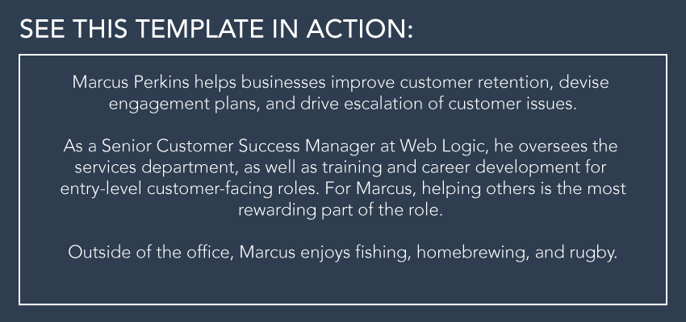

[Name] has been successfully ____, ____, and ____ for over [Number] years.

As the [Job Title] at [Company], he/she has developed ____ and ____ for ____. He/she collaborates with ____ and ____ to ____. He/she also ____ and ____.

In his/her free time, you can find him/her ____, ____, and ____.

[Name] oversees ____, ____, and ____ at [Company]. He/she is a trusted ____ who ____ and ____.

With more than [Number] years of ____ experience, [Name] has worked on several valuable projects, including ____ and ____.

Before joining [Company], [Name] launched his/her career at [Previous Company], where he/she was responsible for ____, ____, and ____. His/her expertise and commitment ____ has allowed him/her to be recognized as a ____.

[Name] graduated with a [Degree] from [School] in [Location].

Combine ____, ____, and ____, and you have [Name]. Serving as a [Job Title] at [Company], [Name] takes on challenging responsibilities, such as ____ and ____.

He/she is a master ____, professional ____, and skillful ____. His/her impressive ____ background allows him/her to ____ and ____, while ____.

In addition to [Number] years in the business, [Name] is also ____. He/she maintains a role in ____ and ____.

Ask him/her about how to ____. It’s his/her secret talent.

An ____, ____, and member of the [Company] family, [Name] is known for wearing a lot of hats. From ____ to ____, he/she can be credited with ____, ____, and ____ in his/her time as [Company]'s dedicated [Job Title].

He/she is a proud alum of [School] where he/she received a [Degree]. He/she loves to visit ____ and spends a lot of time doing ____, ____, and ____.



I joined [Company] in [Year] as the [Job Title].

Prior to [Company], I was the [Previous Title] at [Previous Company] and the [Previous Title 2] at [Previous Company 2]. During my tenure at [Previous Company], I helped the company ____, ____, and ____.

I am a graduate of [School], where I majored in [Degree]. I currently live in [Location] with _____. When I’m not keeping busy with ____, you can find me _____.

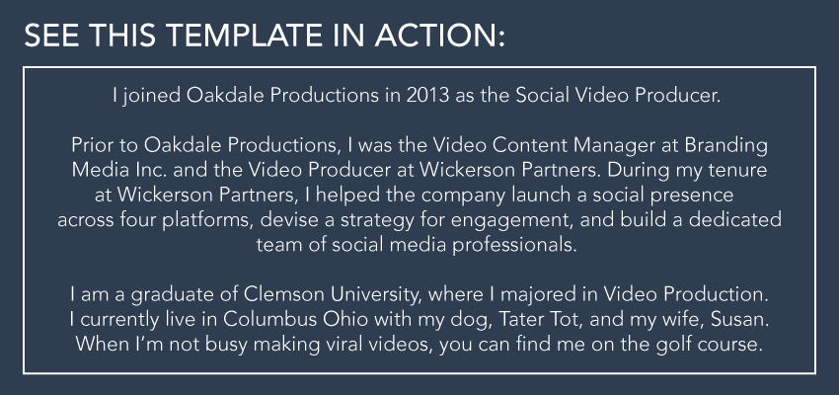

Over the course of my [Number] year career, I’ve worked for companies such as ____, ____, and ____. In [Month + Year], I took on the [Job Title] role at [Company] to help ____ improve ____, ____, and ____.

Since joining [Company], the most rewarding part has been ____, followed closely by ____.

My approach to ___ is largely inspired by ____, which you’ll find reflected in my ___ and ___.

If you’re looking for someone to talk to about ____, reach out on Twitter @YourHandleHere or via email: [Email].

As the [Job Title] at [Company], I am responsible for ____, ____, and ____, while ____. [Company]’s mission is to ____, and I support this by ____, ____, and ____.

In [Year], I successfully executed _____, helping my team achieve ____ in just [Number] months.

I earned a [Degree] in [Focus Area] at [School] in [Location]. Go [School Mascot]!

I believe that ____ requires ____ and ____. In my role as a [Job Title] at [Company], I aspire to live up to this notion by ____, ____, and ____.

With a background in ____, I am passionate about ____ and ____. My professional values can be summed up as follows:
- [Value 1]
- [Value 2]
- [Value 3]

Reach out if you want to talk about ____, ____, ____, or the latest episode of ____: @YourTwitterHandle.

From ____ and ____ to ____ and ____, I’ve developed a deep understanding of ____ over my [Number] years in the ____ industry.

As a ____ professional, I take pride in ____ and thrive on ____. I enjoy working in a ____ environment, as it allows me to ____, ____, and ____.

Currently, I work as a [Job Title] at [Company], where I am focused on ____ and ____. During my time at [Company], I have helped the [Your Department] team ____ and ____, while maintaining ____ and ____.

I run ____ at [Company], which includes ____, ____, and ____. In this role, I oversee ____ and ____, while keeping a close eye on ____.

As a result of this ____ experience, I have a seasoned perspective on how to ____ and ____.

When I’m not keeping busy with ____ and ____, I enjoy ____ and ____.
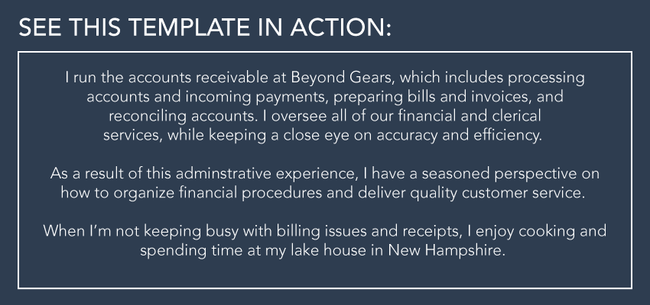

As a [Job Title], I’m responsible for overseeing ____, ____, and ____. I’m particularly involved with ____ and ____, as my primary goal is to ____.

I bring over [Number] years of experience to my role, including experience working with ____, ____, and ____. As a result of this background, my approach is very ____ and I bring a high level of ____ to the work.

Outside of [Company], I am a self-proclaimed ____ who likes to ____ and ____.

As the [Job Title] at [Company], I’m here to ensure we ____ and never ____. Previously the [Previous Job Title] at [Previous Company], I bring a unique perspective to the work we do by pushing the team to ____ and ____.

With a knack for ____ and ____, I’m passionate about finding innovative ways to ____ and ____. As a result, I’ve been recognized by ____ and ____ for my contributions to ____.

I am a [School] graduate with a [Degree] in [Focus Area].

I am a [Job Title] from [Hometown] who currently lives and works in [Location]. I like to consider myself one part ____ and one part ____.
I spent the early part of my career doing ____, before transitioning to ____. Currently, I work as a [Job Title] for [Company], where I joined in [Month + Year].

The best part of what I do? ____. Hands down.

A true ____ in every way, I enjoy spending time doing ____ and ____.

I am a professional ____ who is constantly questioning ____ and ____.
I currently live and work in [Location] by way of [Hometown]. I’m passionate about my role as a [Job Title] because it allows me to ____, _____, and ____.

I’ve been told that I have a great frame of reference in ____, which has helped me ____ and _____ during my time at [Company].

One day I wanted to ____, but until then, I’ll continue to help ____ with ____ and ____, every day.

Want to talk shop? Reach out via Twitter: @YourHandleHere.
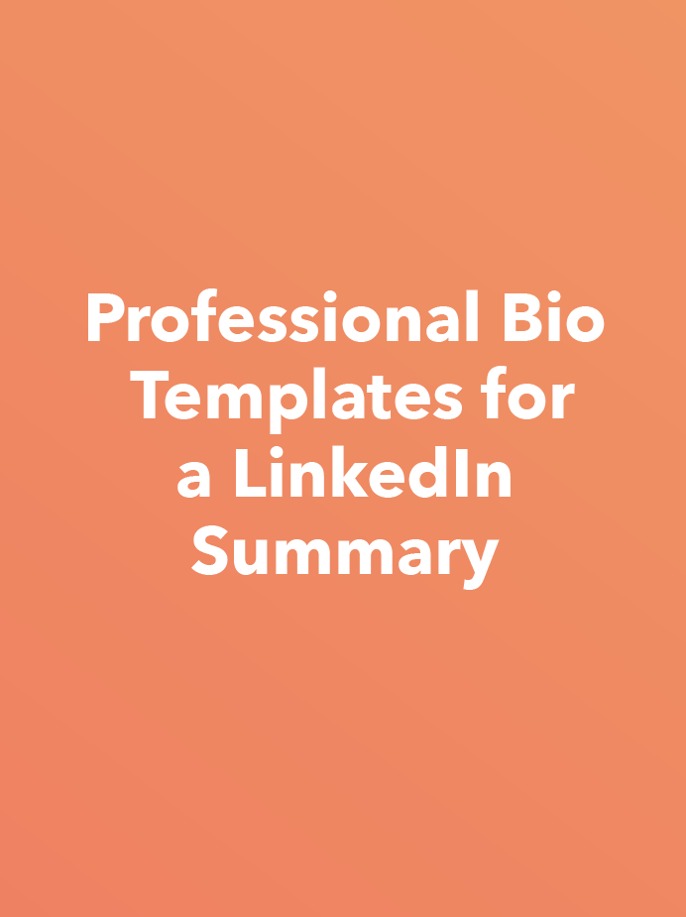

👋 Hi there! I’m [Your Name] – and I’m obsessed with all things ____.

Since [Month + Year], I’ve been a [Title] at [Company], where I’ve focused my time on ____ and ____. While at [Company], my biggest accomplishment has been ____, which ____.

Prior to this role, I was at [Company], where I spent ____ years building ____ for the business and its customers. This work resulted in ____.

I’m always happy to connect with like-minded [Industry] professionals. Shoot me a message – I look forward to hearing from you!

My name is ____, and I’m currently seeking an entry-level role in the ____ industry.

I graduate/d [College] in [Month + Year] with a major in ____. While at [College], I established and grew my passion for ____. Some of the courses that fascinated me most were ____, where I first learned to ____, and ____, where I conducted a semester-long project on ____.

Outside of the classroom, my experience in the ____ club/society allowed me to express my ____ and become a better ____. As the ____ of the ____ club/society, I took a leadership position on campus and ____.

Off-campus, I was afforded the opportunity to intern for ____ as a ____. While at ____, I focused on ____ and discovered I was eager to pursue ____ for a living after graduation.

If you’ve come across my profile, I would love to connect and learn more about opportunities at your organization.

Customers need ____ – that’s where I come in.

As a [Position], it’s my job to help people ____. I’ve been doing it for ____ years and have loved every minute of it.

____ is truly a passion for me. When I was young, I ____. Naturally, this developed into a career in ____, which has led me to where I am today.

In my time as a ____, I’ve worked with great companies like ____, ____, and ____ to improve their ____. If you want to add your name to that list, shoot me a message here on LinkedIn, or email me at [Email].

I’m on the hunt for my new role in ____.

For more than ____ years, I’ve been learning the ins and outs of ____ – what it is, how to be better at it than the rest, and how to help others with it.

It’s for these reasons that I spent ____ years with [Company] as its [Position]. While there, I focused my efforts on ____, ____, and ____, which ultimately resulted in ____.

Now, I’m looking for my next adventure. If you think I’d be a good fit for your organization, please send me an invitation to connect!

When was the last time you thought about ____ in your business?

As a [Position] for [Company], it’s my job to think about that every day. Since [Month + Year], I’ve been [Company]’s point person for ____. During my time here, the company has hit such milestones as:

- [Milestone #1]
- [Milestone #2]
- [Milestone #3]

I’m driven by ____ and ____. I love impactful work, especially when it involves ____.

I’m a ____ guy/girl/person.

My ____-year-long career has been all about ____. Whether it was accomplishing ____ at [Company #1] or growing ____ at [Company 2], I have always put ____ first and been able to drive results.

Currently, I lead a team of ____ at [Current Company]. Our team delivers ____ for ____, which enables the company to ____.

Want to chat about ____ with me? Let’s connect!

In a nutshell, I ____.

In other words, I ____ by ____. In my current role as [Company]’s [Position], I focus on ____. It’s my job to make sure ____.

Professionally, I’m motivated by ____, ____, and ____, which have helped me achieve such accomplishments as ____ and ____.

Outside of work, I recharge by ____ or ____. What I appreciate about my job is being able to pursue both my personal goals and professional passions with equal gusto – honestly, I think it makes me a better ____.

If you’d like to get in touch with me about ____, hit that Connect button and send me a message.

In [Year], I started ____.

Fast forward to today, and I spend every day doing ____.

Presently, I’m a [Position] at [Company] – a ____ company that specializes in ____. As the company’s [Position], I focus on ____, ____, and ____, working with ____ to accomplish ____.

Between my experience in ____, my certification/degree in ____, and my healthy obsession with ____, I consider myself to be a ____.

You can learn more about me on my portfolio here: [Portfolio URL].

Are you a ____ in need of ____?

As a [Position] at [Company], it’s my job to connect ____ with ____. During my ____ years as a ____, I’ve helped ____ of ____ get the ____ they need to ____.

As a result of my work, I’ve been recognized by ____ for my ____, and received the ____ award in [Year]. These achievements are indicative of the work I put in to making ____ better.

Don’t be shy! I’d love to connect with you here on LinkedIn. I look forward to speaking with you about ____.

I am a professional ____ highly skilled in ____, ____, and ____, fully certified in ____.

Currently, I am a [Position] at [Company]. In this position, I ____ by ____. My other work entails ____ and ____.

Prior to this role, I was a [Position] at [Company], where I specialized in ____.

I received my ____ Degree in ____ from ____ in [Year].

